

Robotic inspection of engine blades



Principal Investigator: Dr. Yahya Zweiri  Date: December 2021 | Approved by Director of ARIC:  Date:
Approved by: ARIC Senior Management Board
Date of meeting:

PROJECT DEFINETION
Inspection for blade defects is one of the primary processes during engine MRO. Visual inspection and manual measurement of scratches on the surface of blades is one of multiple inspection methods being conducted in Sanad . The information gained from this step is crucial to determine the severity of blade damage and the usability of the blade itself. However, manual inspection and measurement is expensive in terms of human resources, and is associated with human error. As such, it is desirable to automate this step of the inspection process. The robotics team at Khalifa University has been developing autonomous robotic manufacturing capabilities, and can develop a robotic surface inspection system for blades. This document forms a Statement of work for the collaboration between Sanad and Khalifa University to develop and deploy a robotic surface inspection system for engine blades.

A functional robotic inspection system would require multiple sensors and actuators to successfully perform the surface inspection task. First of which is the sensing elements that captures surface defects. A common option for this sensor is a surface gauge such as the 4D InSpec gauge shown in Figure. 1-a. This sensor can measure surface defects that 4 µm – 2.5 mm deep. Another option that is rising in popularity recently is the GelSight sensor shown in Figure. 1-b; which offers higher precision up to 1 µm. One final option is the proprietary neuromorphic vision-based tactile sensors developed at Khalifa university; which are lower TRL, but are a promising solution for faster and more reliable inspection. Another capability the robot must posses would be the ability to correlate multiple measurements taken on different sections of the blade. This might require a laser tracker system to precisely specify which section of the blade is captured by one measurement. Alternatively, if enough features exist on the surface of the blade, software algorithms such as Iterative Closest Point can be sufficient to correlate the different measurements and would alleviate the need for a laser tracker. Finally, the robot would need to localize one or multiple blades in 3D space, which can be done through a variety of sensors including: rgb cameras, depth cameras, Solid State LiDARS, neuromorphic vision, etc… .In term of actuation, a collaborative robotic serial manipulator will be used to move the surface gauge along the surface of one or multiple blades. A gripping mechanism would be needed to re-orient the blade to gain access to all its faces, and to facilitate the inspection of multiple blades without the need for human support.

Following the above requirements, the robotics team at Khalifa University will develop a customize to the needs of Sanad. The remainder of this document specifies the deliverables, required resource, budget, and timeline for this project.

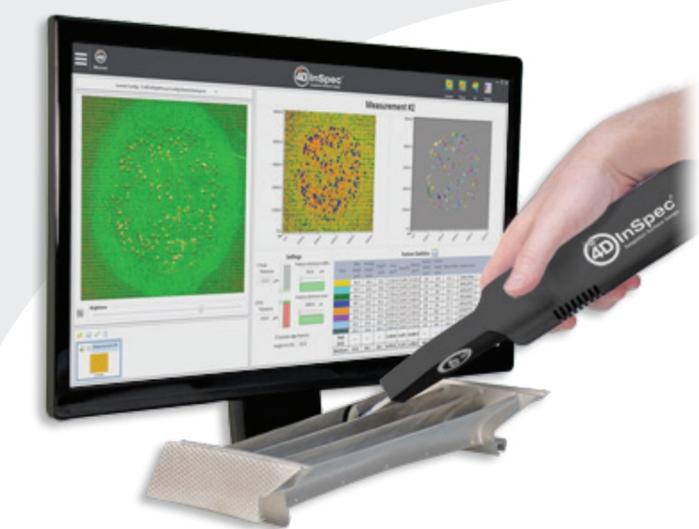 | 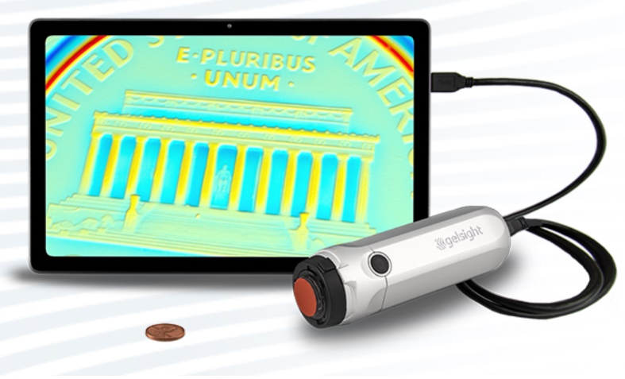
(a) | (b)
Figure 1. (a) The 4D InSpec Surface Gauge from 4Dtechnology. (b) The GelSight Sensor.

OBJECTIVES
- The development of a robotic system capable of performing surface inspection and measurement of surface defects on engine blades with ~5µm precision. Development includes:
  - The customization of an end-effector with machine vision, position tracking, and laser-based surface gauging capability. As an option, the end-effector might need to have gripping capabilities to re-orient the blade to gain access to all faces of the blade.
  - The ability to inspect all faces of multiple blades fully autonomously.
  - The software that guides the robot through the inspection process, including: data collection, re-positioning of blades, and decision-making on the state and health of blades.
- The training of national Khalifa University students on robotic manufacturing technologies, including the mathematical fundamentals, robotic perception, mechanical design and the operation of robots in the industry.

APPROACH
The main components of the robotic sorting system are: perception, manipulation, and a mission management software. A summary of the objectives and approach for each of these subsystems is proved below:

Perception
- Objectives:
- The localization of each blade in 3D
- The surface inspection of blades and measurement of surface defects
- The correlation of measurements takes at different intervals
- The decision-making on blade health
- Approach
- A surface gauge
- Depth camera (intel d435)
- Laser Profilers
- Steady State LiDAR
- Laser tracker (optional)
- Neuromorphic vision

Manipulation
- Objectives:
- Re-orienting blades to gain access to all faces of blades
- The
- Approach
- A collaborative serial robot manipulator
- A customized gripper.

Mission Management
- Objectives:
- The management and coordination of all sub-systems
- Tracking, recording, and reporting progress, faults and defects.
- Approach
- A custom-built software with ROS interface.

DELIVERABLES
- A fully-functional prototype of a robotic system capable of performing surface inspection and measurement of surface defects.
- Full reporting and documentation of the developed system inducing hardware and software.
- A journal paper that targets the use of new technologies for surface inspection.

HUMAN RESOURCES
Resource | Allocation
Dr. Yahya Zweiri (PI) | 10%
1 Research Assistant | 100%
Student Involvement (Undergraduate) | 3 to 4 national students

GANTT CHART
Work Package | Month
 | 1 | 2 | 3 | 4 | 5 | 6 | 7 | 8 | 9 | 10 | 11 | 12
Literature Review & Investigation
Procurement of required equipment
The evaluation, test, and development of surface gauging
The localization of blades in 3D
The gripping end-effector to re-orient and re-position blades
System integration and mission management software
Tests and evaluation
Upgrade of prototype to industrial standard
Project Closure and recommendations

- The Gantt Chart is subject to the date of initiation of the project.

ESTIMATED BUDGET inc all costs such as manpower, opex and capex
CAPEX | 300,000 AED
OPEX | 100,000 AED
Manpower | Equivalent to 1 Research Associate
- CAPEX cost includes the cost of all equipment listed under section 8 of this report, and can be altered according to the final selection of equipment to be purchased.

EQUIPMENT REQUIREMENTS
- A collaborative robotic manipulator (UR10e)
- A surface gauge (i.e. 4D InSpec surface gauge from 4dTechnology or GelSight Mobile)
- High resolution cameras
- Neuromorphic camera
- A laser profiler
- 3D printer for rapid prototyping
- A gripper (vacuum or robotic hand)
- An intel LiDAR Camera L515
- A laser tracker (i.e. the leica at960 system available in the university) (optional)

PROJECT SPECIFIC SMART KPIs
- One journal papers in Q1 journals.
- Fully Functional prototype (hardware & software) for the robotic sorting process
- The training of 3-4 undergraduate students.

PROGRESS REPORTING

- Progress reports - Monthly progress reports will be prepared by the PI and submitted to the project lead per email at the end of each month.
- Interim technical report after 6 months. Final technical report at the end of the project.
- Full documentation of robot hardware & software to be provided at the end of the project.

